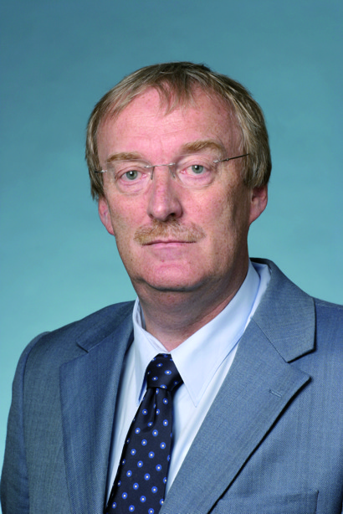
Curriculum Vitae
Joachim Mössner MD, Professor of Medicine

1950 born in Würzburg, son of the ophthalmologist Franz Mössner M.D. and his wife Ursula, maiden name Gunder

School Education:
1957 - 1970
Primary School & High School (Gymnasium of Modern
Languages) in Münchberg / Germany / State of Bavaria
1970 „Abitur“

University:
1970 - 1976 Medical Studies at Julius-Maximilians University in Würzburg/Bavaria
1976 Board Certification („Staatsexamen“)
1978 Medical Thesis “epinephrine and positive inotropy, studies in mouse diaphragm” performed in the laboratory of Professor Dr. Ludwig Heilmeyer jun. / Dep. of Biochemistry, University of Würzburg

Further Training:
1977 Internship Department of Surgery, Community Hospital of Tauberbischofsheim
1978 Internship Department of Internal Medicine (“Medizinische Universitätspoliklinik”), University of Würzburg
1978 „Approbation“
1978 - 1982 Resident, Department of Internal Medicine, University of Würzburg
Clinical Teachers: Professor Hans Franke & Professor Klaus Wilms
1983 - 1985 Stipend of „Deutsche Forschungsgemeinschaft“
Pancreatic receptor research in the laboratories of Professor John A. Williams & Professor Ira D. Goldfine at the Dep. of Physiology, University of California, San Francisco
1986 Board Certification: „Internist“
1987 „Habilitation“ and „venia legendi“ - title: „Privatdozent“
Thesis: Endocrine-exocrine functional axis - a hypothesis?
1988 Board Certification: „Gastroenterologist“
1986 - 1993 Head of the Gastroenterology Unit at “Medizinische Universitätspoliklinik” Würzburg
1989 Full Professor of Medicine („C3- professorship“)

Main interests in basic research:
Granted by „Deutsche Forschungsgemeinschaft“, stipends of the „Alexander-von Humboldt-Stiftung“, BMBF (German Ministry of Science), and Industry:
Role of steroids in regulation of the exocrine pancreas
Role of lipophilic substances in regulation of cellular integrity and functions of the exocrine pancreas
Cell cycle regulation
Pathogenesis of acute pancreatitis
Hereditary chronic pancreatitis
Genetic risk factors for the development of pancreatitis

Main interests in clinical research:
Chronic pancreatitis, pancreatic carcinoma, bile duct cancer, colon cancer, reflux disease, interventional endoscopy

Awards:
1985 „Konstanzer Medizinischer Förderpreis“
1988 Martin Gülzow Award of the German Society of Gastroenterology
1999 Member of the „Deutsche Akademie der Naturforscher Leopoldina“ (National German Academy of Sciences, Leopoldina)
2002 Honorary Member of the Polish Society of Gastroenterology
2005 Honorary Member of the Czech Society of Gastroenterology
2006 Member of the Saxonian Academy of Sciences

Editorial board responsibilities:
Pancreatology, European Journal of Clinical Investigation, Journal of Gastroenterology (official journal of the Japanese Society of Gastroenterology up to 2002), Medizinische Klinik, German Journal of Gastroenterology, Der Internist, Chirurgische Gastroenterologie/Visceralmedizin, CME

Board responsibilities of scientific associations:
German Society of Gastroenterology (until 2006); “Mitteldeutsche Gesellschaft für Gastroenterologie” (treasurer), Gastro-Liga; Association of patients with pancreatic resections; United European Gastroenterology Federation (1998 – 2003); Deutsches Ärzteblatt, member of the “Kollegialorgan”, section 4 (genetic, metabolic and regulatory basis of diseases and public health) of the “Deutsche Forschungsgemeinschaft (2004- 2011), DFG” responsible for reviewing of grant applications

Member of scientific societies:
German
German Academy of Natural Sciences (Leopoldina); German Society of Cancer Research; German Society of Endoscopy; German Society of Gastroenterology; German Society of Internal Medicine; German Pancreatic Club; Society of Progress in Internal Medicine (“Ludwig-Heilmeyer”-Society); Saxonian Academy of Sciences,
International
American Gastroenterological Association, European Pancreatic Club; European Association for Gastroenterology and Endoscopy; elected member of European Pancreatic Club for the General Assembly of the United European Gastroenterology Foundation“;International Association of Pancreatology;

Publications:
Original articles, peer reviewed: 186
Reviews: 173
Case reports & Letters to the Editor: 073
Symposia: 066
Book articles: 054
Editor of Books: 006
Scientific political articles: 010
Published abstracts: 533

Since November 1st 1993
Full Professor of Medicine („C4-professorship“)
Director of the Division of Gastroenterology & Rheumatology
Department of Internal Medicine, Neurology and Dermatology
University of Leipzig

1996 - 1997 Vice Dean, Medical Faculty of Leipzig
1997 - 2002 Dean
1999 President of the German Society of Gastroenterology
2002 President of the „Middle German“ Society of Gastroenterology
2004 -.2010 President of the Saxonian Society of Internal Medicine
2011 - 2012 President of the German Society of Internal Medicine

Address
Universitätsklinikum Leipzig, AöR
Department für Innere Medizin, Neurologie und Dermatologie
Medizinische Klinik und PoliIklinik für Gastrotenrologie und Rheumatologie
Liebigstraße 18
04103 Leipzig
Tel.: 0049 (0) 341 97 12 200
Fax: 0049 (0) 341 97 12 209
Email: moej@medizin.uni-leipzig.de

Leipzig, December 11, 2010 Professor Dr. med. habil. Joachim Mössner

